**ENACH REQUEST TO FTP**

Under the **Account** menu, the page titled **"Each Request to FTP"** provides users with the ability to manage and process FTP (File Transfer Protocol) requests associated with their accounts. This page enables users to view, track, and initiate FTP-related operations effectively. It is typically used for managing the transfer of files between systems or servers through FTP, ensuring that requests are handled and processed accurately

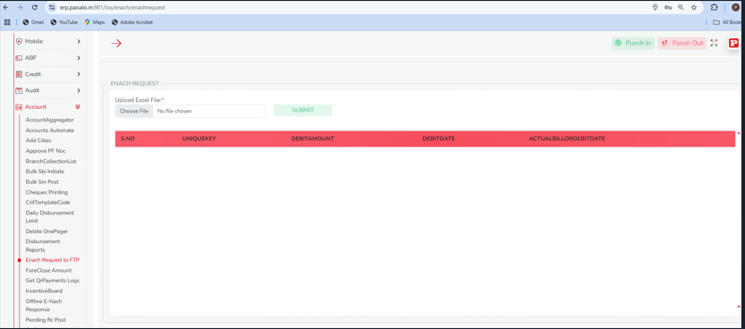

Upon accessing the page, users are presented with a field labeled **"Choose File"**. This allows users to select the relevant file containing the data they wish to upload. Once the file is selected, users can submit it using the **Submit** button.

After the file is successfully submitted, the system processes the data and displays it in a table format. The table includes the following key columns for easy review and analysis of the uploaded information:

* **Serial Number**: A unique identifier for each entry in the uploaded file.
* **Unique Key**: A distinct key assigned to each record for tracking and referencing purposes.
* **Debit Amount**: The amount of debit specified in the uploaded data.
* **Debit Date**: The date on which the debit transaction was recorded.
* **Actual Bill Order Debit Date**: The date on which the actual bill order debit is processed.

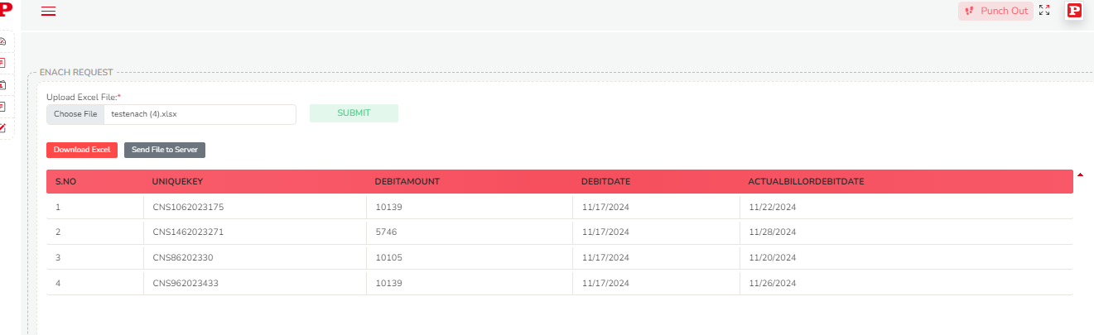

The **"Each Request to FTP"** page also offers two additional functionalities to enhance user experience in managing FTP file transfers:

1. **Download Excel File**:  
   Users can download a pre-formatted Excel file by selecting the **Download Excel File** option. This file contains the necessary structure and fields for users to fill in relevant data. Once the data is entered into the Excel sheet, users can upload it back to the system.
2. **Send File to Server**:  
   After completing the required data entry in the Excel file, users can upload the file directly to the main database server by selecting the **Send File to Server** option. This facilitates the transfer of the processed file from the user's local system to the central server for further processing and integration.

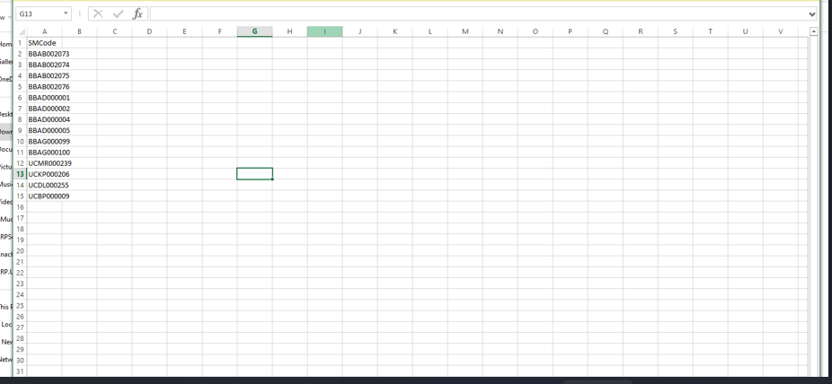

These functionalities streamline the process of data entry and transfer, allowing users to efficiently download, populate, and send files to the server without the need for manual data entry into the system. This process ensures that large sets of data can be quickly and accurately transferred to the main server for processing under the **eNACH Request to FTP** process.